

Techneco Elga heat pump

**User manual**

Version 15.3

Associated with firmware version 15.3 and higher

28-7-2017

# Table of contents

1. Introduction1
2. Control indoor unit2
3. Set up thermostat3 
   1. Check setting3
   2. Cooling or heating with thermostat3 
      1. Heating only4
      2. Cooling only4
      3. Automatic cooling and heating4
4. Thermostat settings recommendations5 
   1. General5
   2. Weather dependent control and Optimal Comfort5
   3. Reduced temperature5
5. Possible malfunctions6

#### Supplier

Techneco Energiesystemen BV Kleveringweg 9

NL-2616 LZ Delft

T: 015-2191000

E.: [info@techneco.nl](mailto:info@techneco.nl)

W: [www.techneco.nl](http://www.techneco.nl/)

#### Disclaimer

This document is subject to change and is subject to change without notice. Although the utmost care has been taken in compiling this document , it cannot be guaranteed that the information is complete, up-to-date and/or accurate. No rights can be derived from this document.

# 1Introduction

Congratulations on your purchase of the Elga air/water hybrid heat pump. This user manual first covers the operation of the indoor unit. After that, the main functions of the included Honeywell Chronotherm Vision Modulation room thermostat are treated.

#### Components

The Elga heat pump consists of a number of components, namely :

* Elga indoor unit
* Toshiba outdoor unit
* Honeywell Chronotherm Touch Modulation room thermostat

The Elga heat pump is installed and connected to :

* The already installed central heating boiler or district heating
* The already existing delivery system

#### Heat pump principle

The heat pump uses the outside air as a (free) energy source to heat central heating water . The outside air is blown through a heat exchanger (evaporator) with the help of a fan. The liquid refrigerant present in the evaporator absorbs the heat of the outside air and evaporates. The vapour is sucked in and compressed by a compressed acid, causing the pressure and temperature to rise. The vapour is transported to the indoor unit via the pipes. In the indoor unit there is a second heat exchanger (condenser). Here the vapor condenses again into liquid. This provides the energy to heat water. With an expansion valve, the pressure and temperature of the refrigerant are lowered again and the cycle starts from the beginning.

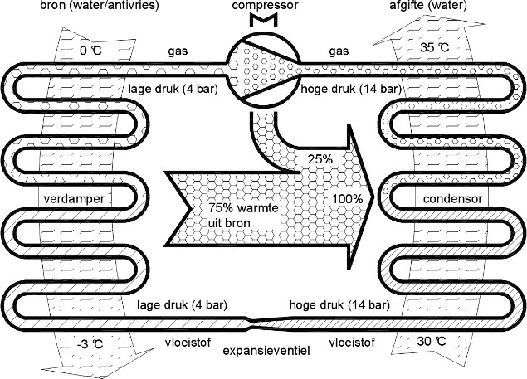Bee refrigeration becomes the circuit in the outdoor unit turned over.

An important concept in heat pumps is the "Coefficient or Performance (COP)". It is the ratio between yellow-dyed (heat) power and supplied electricity. The higher the COP, the Better. In Figure 1, the COP is: 100% / 25%

= 4. The 75% source energy is "free" ambient heat. An energy-efficient way or heating.

***Figure 1: Heat pump principle***

#### Arrangement

The supplied room thermostat is connected to the control of the Elga. The central heating boiler is also connected to the Elga. If there is heat demand from the room thermostat, the Elga determines whether heating is done with the heat pump and/or with the central heating boiler .

The regulation of the Elga aims to maximize energy savings while maintaining comfort. To achieve this, the heat pump is used as much as possible to keep the house at temperature . If large temperature increases are required (heating up more than 1°C), the central heating boiler will be controlled to maintain comfort.

The COP of a heat pump depends on the temperature difference between the source (outside air) and the release (central heating water). At an outside temperature lower than about 4 °C, the savings with the heat pump are minimal and therefore at lower temperatures than 4 °C only the central heating boiler will heat the house. This restriction can be set or disabled by the installer.

# 2Control control indoor unit

At the front of the Elga indoor unit is the control panel, see figure 2. In Table 1, the operation is

of the push buttons and LEDs .

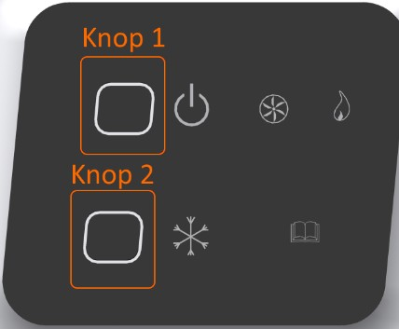

***Figure 2: Elga control display***

|  |  |
| --- | --- |
| **Symbol** | **Function** |
|  | **On/off button 1 (Red LED)**  LED on: the heat pump is switched on and will function together with the boiler for heating.  LED off: the heat pump is switched off. Only the central heating boiler will be used for heating.  LED flashes: Elga is externally blocked for heating, for example by an external after-control. Or the scheme is starting up. |
|  | **Release cooling button 2 (Blue LED)**  LED is lit: the heat pump can be used for cooling.  LED flashes: Elga is externally blocked for cooling, for example by an external after-control .  LED is not lit: the heat pump cannot be used for cooling. |
|  | **Business indication outdoor unit (Green LED)**  Off: the outdoor unit is in standby On: the outdoor unit is in operation  Flashing: Toshiba is not running yet while there is demand (pre-turn time or disabled due to maximum temperature). |
|  | **Operating indication boiler (Orange LED)**  Off: the boiler is on standby On: the boiler is in operation  Flashing: there is enough demand on the thermostat to use the boiler , but the boiler is off because, for example, the water temperature has reached the set point. |
|  | **Interference (Yellow LED)**  Off: the Elga has no malfunction.  Flashing: The Elga has a malfunction and is locked.  In the event of a malfunction, warn the installer and turn off the Elga with button 1. |

***Table 1: Operation instruction Elga***

# Set up thermostat

### Check setting

Because the Elga is a device that can also cool, the cooling function of the thermostat in the installers menu must be active. Even if you do not want to use the cooling functionality.

To check whether the cooling function in the installers menu is active, press 'SET' on the screen.

***Figure 3: Basic screen room thermostat***

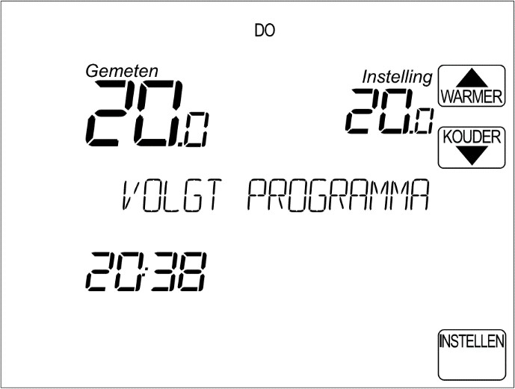

In the setting screen below, the button should be  visible.

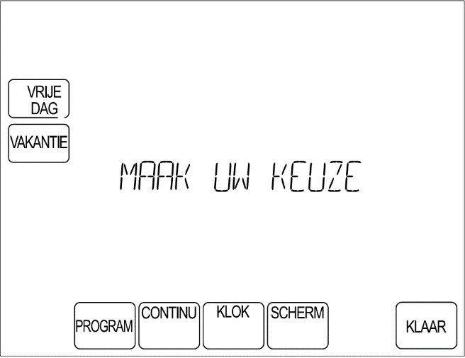

***Figure 4:*** Room  ***thermostat adjustment screen***

If the button  is not visible, the cooling function in the installers menu must be activated. This is necessary for the proper functioning of the Elga.

If the 'COOL HEAT' button is not visible, consult your installer.

### Cooling or heating with thermostat

When the settings are set correctly by the installer, the user can easily switch between the following functions:

* + - HEATING ONLY
    - COOLING ONLY
    - CAR COOL/HEAT

To do this, press 'SET' from the basic screen. Then press the button 'COOL HEAT' (see figure 4). Then you can make your choice. Confirm the choice with the 'DONE' button and the setting will take effect after 7 seconds.

## Heating only

In this function, the temperature set (top right "***Setting***") must be equal to or higher than the measured temperature (top left "***Measured***") to activate the Elga and/or boiler . When the set temperature is lower than the measured temperature, the Elga and the central heating boiler will not heat. On the room thermostat, the term HEATING will appear at the set temperature . When there is heat demand and the Elga/central heating boiler will supply heat, the thermostat indicates a flame (figure 5).

## Cooling only

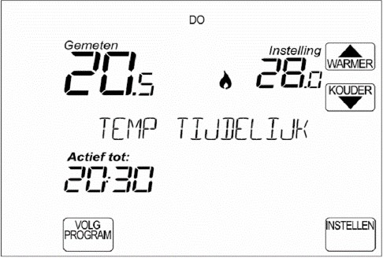

Boiler is in tap water supply (OT boilers only)

Heating | Active with Elga And/or boiler

Cooling Active

***Figure 5: Basic screen room thermostat with status indications***

In this function, the set temperature (top right "***Setting***") must be lower than the measured temperature (top left "***Measured***"). When the set temperature is higher than the measured temperature, the Elga will not cool. Also, the Elga and central heating boiler will not heat. The tap water function remains available.

On the room thermostat, the term COOLING will appear at the set temperature. When there is cold demand and the Elga will deliver cold, the thermostat indicates an ice crystal (figure 5).

## Automatic cooling and heating

In the AUTO COOL/VERWARM mode, the thermostat will determine when cooling or heating is needed. For this, two temperatures must always be set. The thermostat will try to keep the room temperature between these two set values.

#### Desired heating (lower limit)

If the room temperature drops to or below "Desired heating", the thermostat will control the Elga for heating so that it does not get colder than the "Desired heating" temperature.

For example, 20°C.

#### Desired cooling (upper limit)

If the indoor temperature rises above the "Desired cooling ", the thermostat will control the Elga for cooling.

For example, 24°C.

#### Heating /cooling dead belt

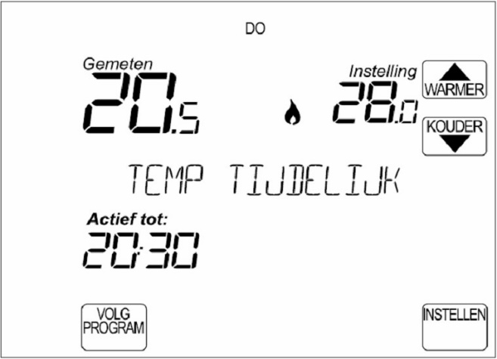

The thermostat will automatically maintain a difference of mini-times 4°C between "Desired cooling" and "Desired heating". This bandwidth is fixed. If the desired room temperature for cooling is set lower, the desired temperature for heating automatically drops with it.

If the thermostat is set to **AUTO COOL / WARM,**  you can set the lower and upper limit in the base screen by pressing the 'COOL WARM' button **in the basic screen**  (figure 6 ). The text below the desired temperature will then switch between heating and cooling. If it says "Heating", this means that "Desired heating" can be set at that time.

***Figure 6: Basic screen room thermostat***

# Thermostat settings recommendations

### General

The regulation of the Elga has a number of starting points with regard to control of the central heating boiler. The central heating boiler is only used if:

* + - * The outside temperature is 4°C or lower or
      * The set temperature is 1°C higher than measured temperature or
      * The room temperature for 30 minutes 0.5°C is lower than desired.

If night reduction is applied, the requested temperature "shoots up" in the morning. If this jump

is larger than 1 °C , the central heating boiler will always be added to bring the house to temperature .

To prevent the central heating boiler from recovering in the morning, you can apply a smaller night reduction of 1 °C. If the indoor temperature threatens to fall below the set value, the heat pump will start to keep the temperature above the desired one. The central heating boiler will then not have to switch on in the morning.

See also chapter 4.3 on the reduced temperature.

### Weather-dependent control and Optimal Comfort

The included room thermostat supports "weather dependent control" and "Optimal Comfort" control. The Elga heat pump does not support the "Optimal Comfort", because the Elga regulates based on the difference between measured and desired room temperature. In consultation with the installer, the Elga can be set up for weather-dependent control.

### Reduced temperature

If the "reduced temperature" function is activated on the Elga, the control will recognize a set temperature below 19°C as "reduced temperature". The Elga will then only use the heat pump to maintain this temperature in the house (provided that the outside temperature remains above 4 °C). The reduced temperature function allows you to apply a smaller night reduction without consuming gas at night.

The usefulness of applying night reduction is very dependent on the insulation value and type of delivery system of the house. In well-insulated homes with underfloor heating, it is generally advisable to apply little or no night reduction.

For homes with normal or poor insulation and radiators, the application of night reduction is advisable.

# Possible malfunctions

If the Elga has a malfunction, the yellow LED on the front of the indoor unit will flash 9 times. One or more blinks last longer. This is an indication of which malfunction is occurring. Between the 9th and 1st blink there is a longer pause (there is no LED).

***Table 2: Fault indication yellow LED***

|  |  |  |  |
| --- | --- | --- | --- |
| **Indication Elga** | **Thermo-condition** | **Fault description** | **Possible solution** |
| 1st blink long | 1 | The central heating boiler reports to the Elga that there is  is a malfunction (ot boilers only) | Look in the manual of your central heating boiler what  the malfunction is |
| 2nd blink long | 2 | Communication problem with  OT central heating boiler | Contact your installer |
| 3rd blink long | - | Communication problem with  OT thermostat | Contact your installer |
| 4th blink long | 8 | Communication problem with  Toshiba Print | Contact your installer |
| 5th blink long | 16 | Toshiba print has an error indication | Contact your installer |
| 6th blink long | 32 | Flow failure Elga | Check that all valves are open and the system is pressurized. Open valves and refill if necessary. Vent it  system. Otherwise , contact your installer. |
| 7th blink long | 64 | Interference temperature sensor return  (NTC1) | Contact your installer |
| 8th blink long | 128 | Interference (extra) outdoor sensor (TRB) | Contact your installer |
| 9th blink long | 4 | Failure temperature sensor supply  (NTC2) | Contact your installer |

If any of the above malfunctions occur, the thermostat will say "BOILER FAILURE" (figure 7). This means that the Elga scheme registers a malfunction.

Now press "INFO", the thermostat will display an error code (see second column in table 2). An explanation for the fault code can be found below. If there are multiple failures, the error code displayed will be the sum of error codes .

For other thermostat notifications , refer to the thermostat's manual .

If a malfunction occurs, the Elga will stop heating. By turning off the Elga with the on/off button, only the central heating boiler will be used for heating.

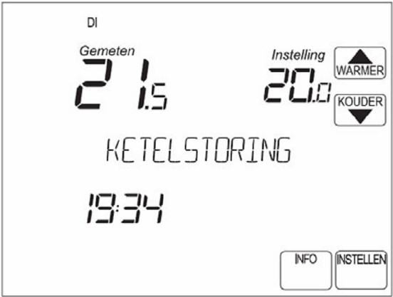

***Figure 7: Basic screen room thermostat with fault indication***

# Installer data

Company:

Installer:

Address:

Place:

Telephone number:

Fax:

Email:

**Space for notes**